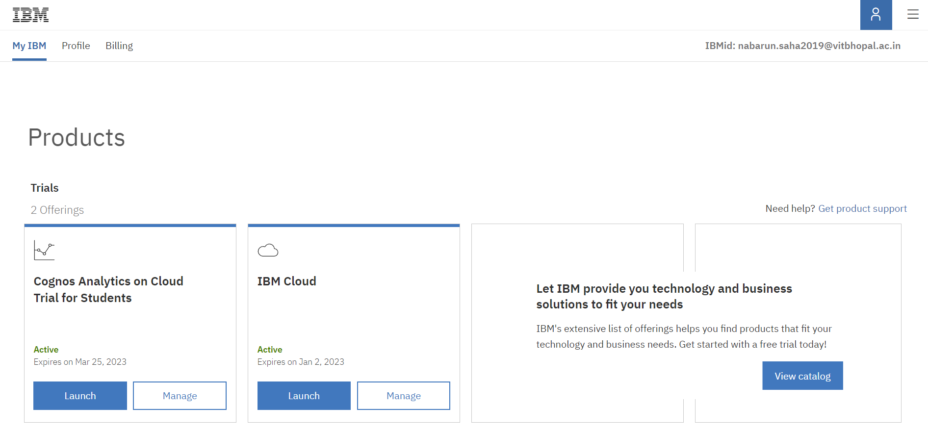Task 1: IBM Account Creation

Task 2: Create Cognos Analytics Account

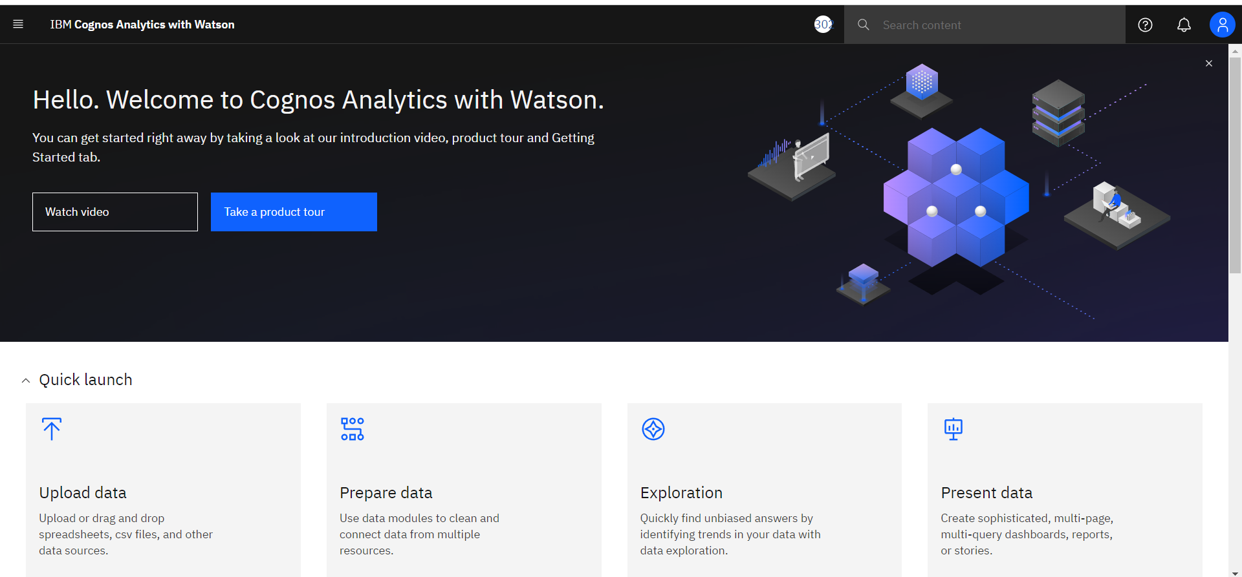

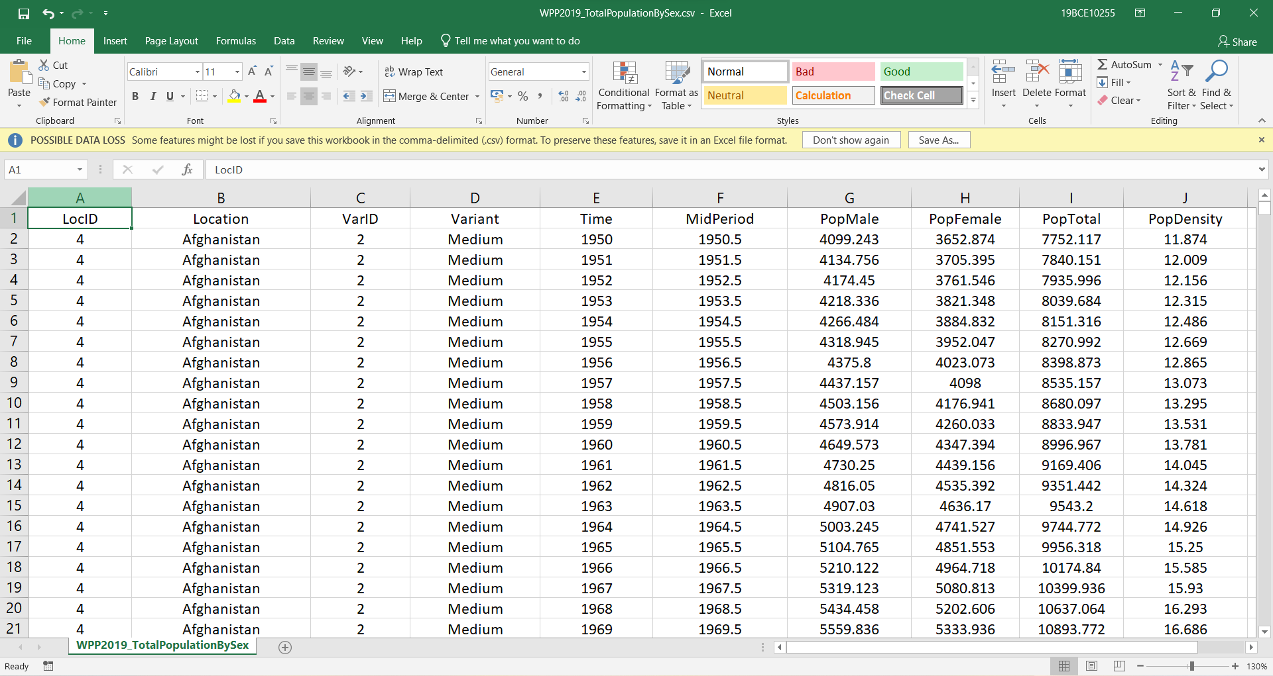Task 3: Understand The Dataset

Task 4: Loading The Dataset

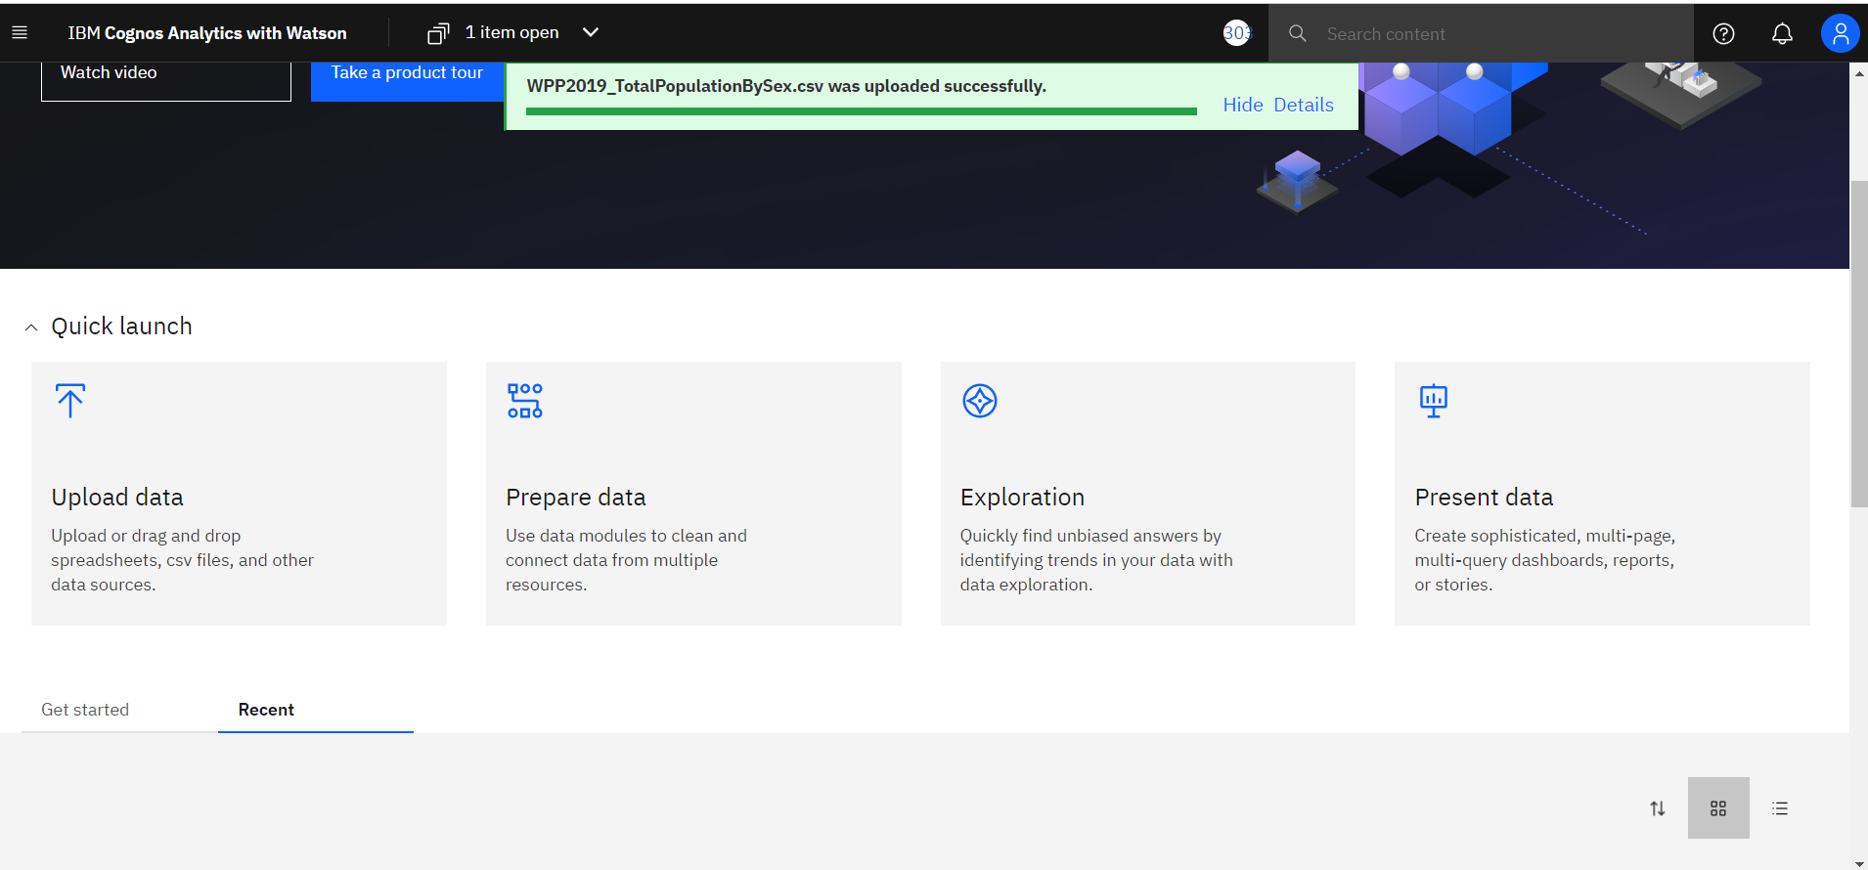

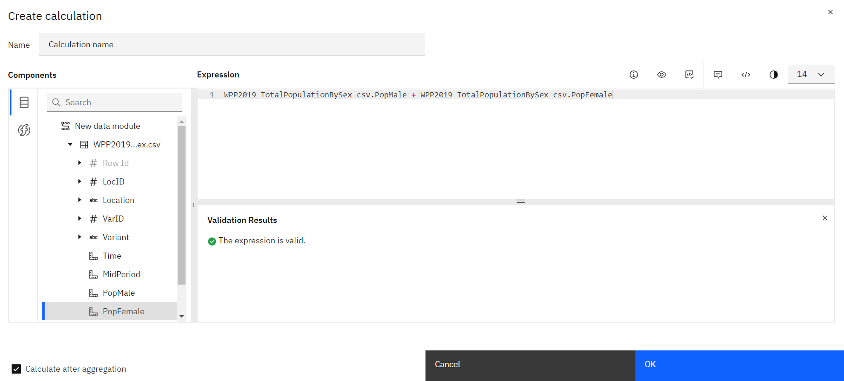Task 5: Prepare The Dataset

Task 6: Top10 Pop Total By Location Using Tree Map

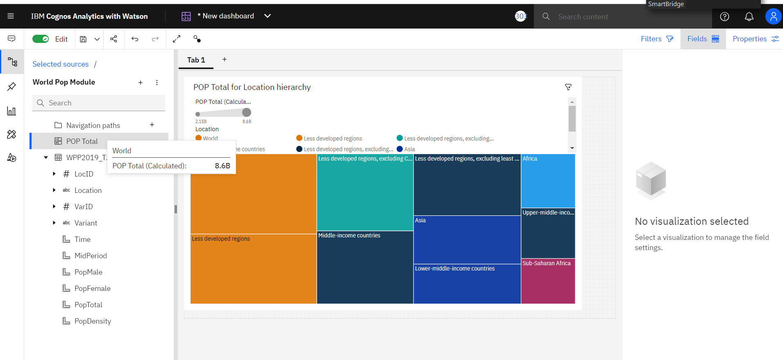

Task 7: Pop Total By Time Using Line Chart

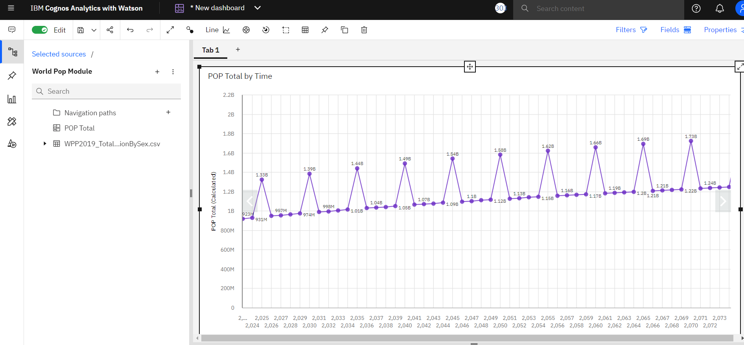

Task 8: Pop Male By Location And Pop Female By Location Using Pie Charts

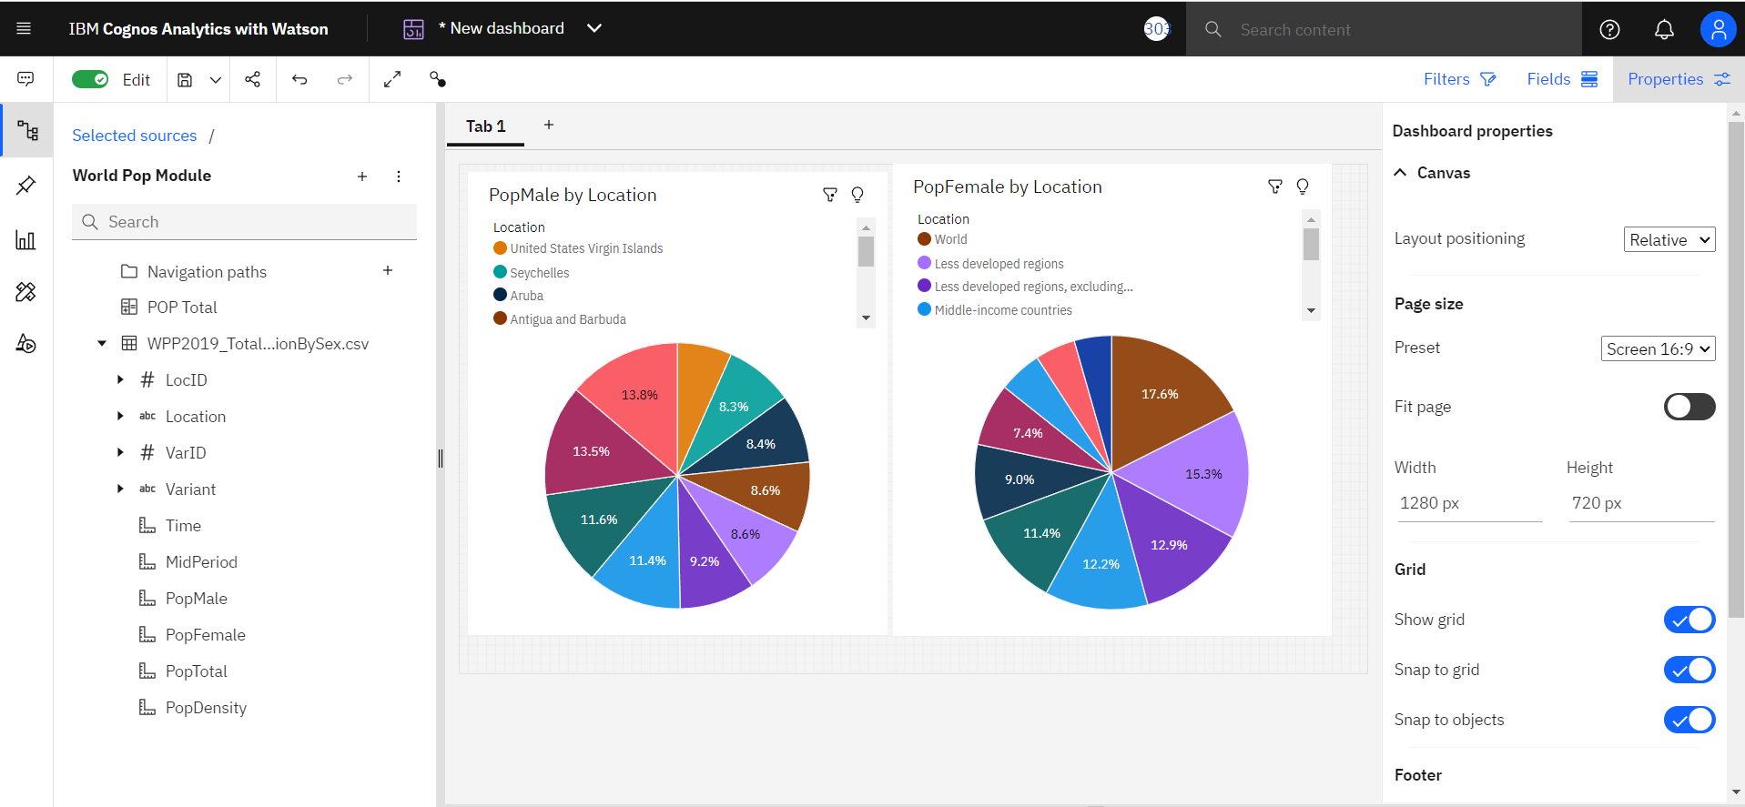

Task 9: Pop Male By Time And Pop Female Using Packed Bubble Charts

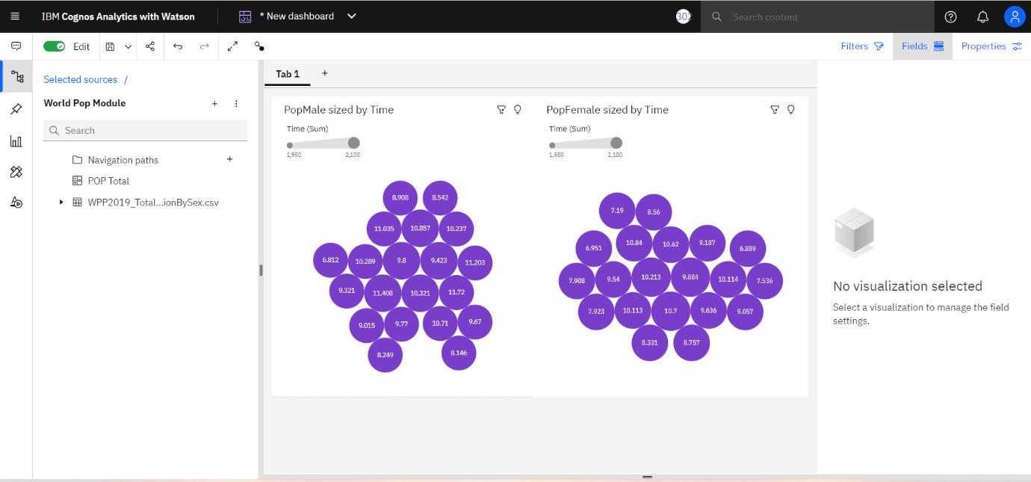

Task 10: Building Of Dashboard

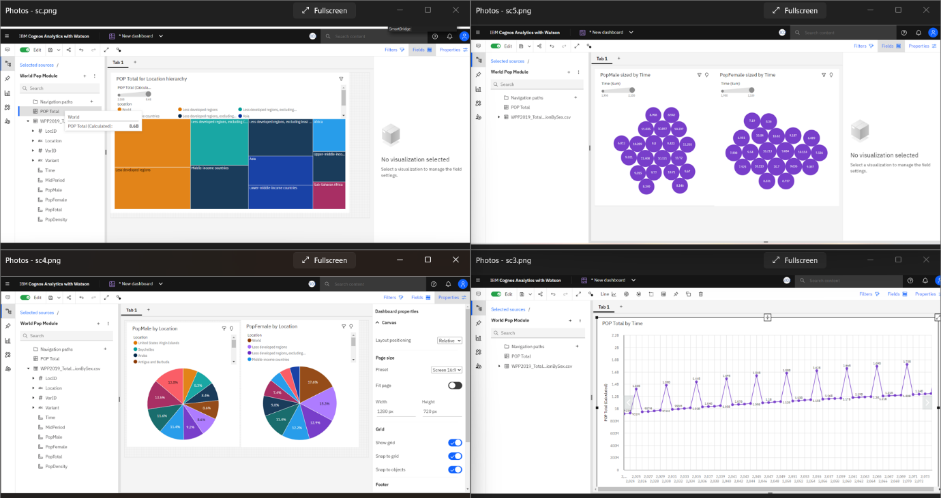

Task 11: Pop Male, Pop Female And Pop Total Using Summary

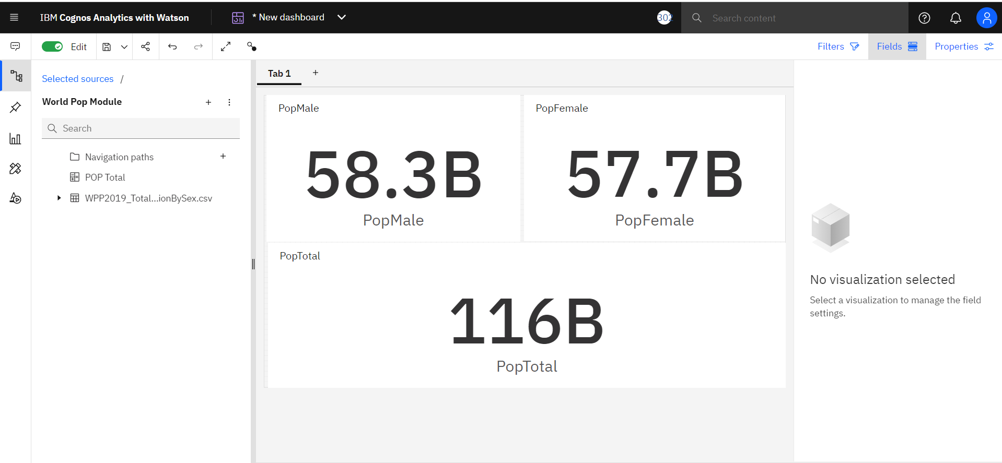

* Conclusion

The 2019 Revision of World Population Prospects is the twenty-sixth round of official United Nations population estimates and projections that have been prepared by the Population Division of the Department of Economic and Social Affairs of the United Nations Secretariat is displayed.

The results are presented in a series of Excel files displaying key demographic indicators for each UN development group, World Bank income group, geographic region, Sustainable Development Goals (SDGs) region, sub region and country or area for selected periods or dates within 1950-2100.

List of sources of empirical data used or considered and the methods applied in revising past estimates of population and components of demographic change (fertility, child, adult and overall mortality, international migration) are presented in tabular form for each demographic component and country or area for the period 1950-2020.

The analysis of the dataset is being done using various visualizations and templates by which we can get some preliminary idea about how the Population of UN is being effected with time.

* Advantages:

1. It helps to visualize the different dataset of the World Population Module.
2. Gives a better idea about visualizations using Smart Bridge Platform.
3. Gave a better understanding about IBM Cloud and IBM Cognos using Watson where the data is being prepared.

* Disadvantages:

1. The data set is too large such that many false information may lead to mis interpretation of the dataset.
2. The world population is increasing years after year and which has to be controlled.

\*\*\*\*\*\*\*\*\*\*\*\*\*\*\*\*\*\*\*\*\*\*\*\*\*\*\*\*\*\*\*\*\*\*\*\*\*\*\*\*\*\*\*\*\*\*\*\*\*\*\*\*\*\*\*\*\*\*\*\*\*\*\*\*\*\*\*\*\*\*\*\*\*\*\*\*\*\*\*\*\*\*